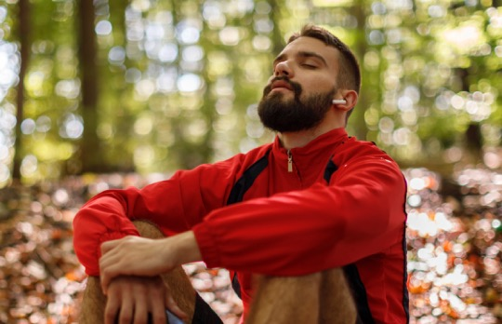

**Be your best self**

You want to be there to support friends and loved ones, and you want to feel present for all of life’s moments. But sometimes, that’s easier said than done.

**myStrength** and **Wellbeats** will help you build good mental health habits with mindfulness techniques, sleep and nutrition advice, endorphin-boosting exercise programs and more.

Completing well-being activities can also help you earn your [HealthPartners Living Well or client program name] reward.

For questions, contact [group contact name] at **[number]**.

Take your health assessment to access the activities and more at **healthpartners.com/signin/livingwell** or use the myHP app.