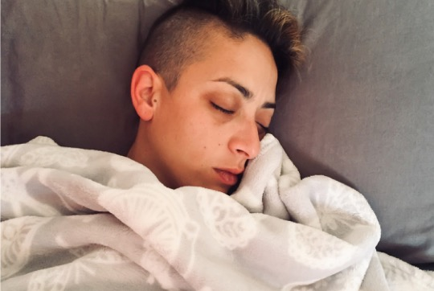

**Rest easier**

When you wake up well-rested and refreshed, you feel like you can accomplish almost anything. Quality sleep is also essential for maintaining good overall health.

Improve your sleep habits with **Sleep Tracker** and **myStrength**. These well-being activities can help you learn how to get a restful night’s sleep while tracking your progress along the way.

Completing well-being activities can also help you earn your [HealthPartners Living Well or client program name] reward.

For questions, contact [group contact name] at **[number]**.

Take your health assessment to access the activities and more at **healthpartners.com/signin/livingwell** or use the myHP app.